What is Dice rolling? Dice (from Latin: datum meaning "to be given or played") is a small object, generally cube-shaped, which is used to generate random numbers or symbols. Dice are used in a variety of children's and gambling games. Generally, dice are used in pairs. Traditional cube-shaped dice are often rounded corners and have a different number or symbol on each side. Dice are designed to give one random round number from one to six with equal probability. Traditionally, pairs of numbers with the sum of seven are made on opposite sides.

#include <iostream>

#include <cstdlib>

#include <ctime>

int main() {

srand(time(0));

std::cout <<" Welcome to Dice rolling "<< std::endl;

while (true) {

std::cout << "Gulirkan dadu (y/n)? ";

char jawaban;

std::cin >> jawaban;

if (jawaban == 'n')

break;

if (jawaban == 'y') {

int angka = rand() % 6 + 1;

std::cout << "Angka dadu: " << angka << std::endl;

} else {

std::cout << "Masukkan jawaban yang valid (y/n)!" << std::endl;

}

}

return 0;

}

When the code is run, it will display output like the following:



int main() {

srand(time(0));

What is Srand? srand or rand is a function used to retrieve random numbers. Srand or rand is commonly used like looking for dice numbers because the dice numbers come out not sequentially but randomly

while (true) {

std::cout << "Gulirkan dadu (y/n)? ";

char jawaban;

std::cin >> jawaban;

if (jawaban == 'n')

break;

if (jawaban == 'y') {

int angka = rand() % 6 + 1;

std::cout << "Angka dadu: " << angka << std::endl;

Then in the coding there is a while, the while is used if in the coding there is a correct choice or not, if the while choice is correct the possibility of the while function will run until the logic of the while function is wrong, so the coding will stop. Why is there + 1 in this program, + 1 for the numbers taken out of the random there is no 0 or you can say that the random numbers are added 1. If + 1 is removed, then there is a possibility that the number 0 will appear.

In this coding we are given 2 choices, namely Y or N. where Y is to run or play dice rolling and N is not to play dice rolling. and if you choose Y then the output will look like this

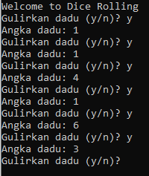

else {

std::cout << "Masukkan jawaban yang valid (y/n)!" << std::endl;

}

Then, what is the function of else here? The function of the else is when the player doesn't choose Y or N but instead chooses another letter or number. Then the player will be displayed with the sentence **Masukan jawaban yang valid (y/n)** as shown below.

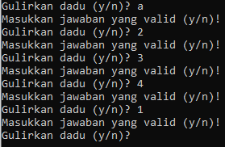

And finish for project dice rolling program.